Shabbos Stories for
Parshas Pinchos 5783
Volume 14, Issue 43 – 19 Tammuz 5783/July 8, 2023
Printed L’illuy nishmas Nechama bas R’ Noach, a”h
For a free subscription, please forward your request to keren18@juno.com
Past emails can be found on the website – ShabbosStories.com

Of Blessings and Socks
By Rabbi Paysach J. Krohn
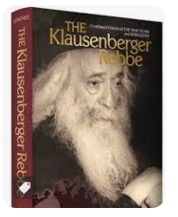

The Klausenberger Rebbe, R’ Yekusiel Yehuda Halberstam, was known for his profound compassion for any Jew with a broken heart. Thousands were soothed and encouraged by the Rebbe in the concentration camps and the DP camps. The Rebbe, who himself had suffered unimaginable horrors, helped the exhausted and hopeless Survivors in the DP camps by organizing minyanim, learning Torah with whomever he could, and comforting the masses.
On Erev Yom Kippur in 1947, the Rebbe was interrupted from his holy preparations by a knock on the door of a young girl with tears in her eyes. “Rebbe, every year my father would bless me before Yom Kippur. My father was burned alive and I have no one to bless me.”
The Rebbe, who had lost his own wife and 11 children, invited the girl to come in and said, “My child, I will be your father.” He put a handkerchief on her head, and with his holy hands he blessed her, emotionally and intently. The girl left the Rebbe’s quarters smiling and fortified.

The News Soon Spread and Many Girls
Came to Get the Rebbe’s Sincere Blessings
A few minutes later a group of forlorn girls came to the Rebbe and asked to be blessed as well. Once again, with patience and tears, he blessed each girl. The news spread and soon orphaned girls of the DP camp were coming in droves. The Rebbe blessed every single one of them – 87 in all!
By the time he ended, the Rebbe had little time for personal preparation for Yom Kippur. But what better way could there be to prepare for the holiest day of the year than to spend the day comforting broken-spirited orphans?
When the family of the Klausenberger Rebbe was sitting shivah in Israel after his passing, a woman came to be menachem aveil, carrying a bag. As she sat down among the women, she told the following story:
In the DP camps, the Rebbe was a beacon of light and comfort for all the Survivors. One day, as the Rebbe was walking through one of the camps, he saw a young Jewish girl walking without stockings. She was speaking Yiddish, and it was clear that she was Jewish.
“Mein tuchterel,” the Rebbe said to her, “dee bist duch ah bas Yisrael. (My daughter, you are a Jewish girl, and we have a Shulchan Aruch. It is not proper for a Jewish girl to go without stockings, my child.)”
The girl said to the Rebbe, “I should have stockings? I don’t have bread to eat. Where should I get stockings?”

The Rebbe’s Sock Solution
The Rebbe sat down on the ground, took off his shoes and socks, and gave the socks to the young girl. “Now, my child, at least you have stockings,” he said. The woman telling the story paused for a moment and then, opening the bag, said, “I was the girl, and these are the socks.” (Excerpted from the ArtScroll book – “Along the Maggid’s Journey”) The yahrzeit of R’ Yekusiel Yehuda ben R’ Tzvi Hirsh, the Klausenberger Rebbe zt”l, is on 9 Tammuz (1994). May his merit protect us.

Reprinted from the Parshas Chukas-Balak 5783 email of The Weekly Vort.

The Story of Sam, Who Gives Out Blue Bracelets and Bike Helmets
As told to Sori Block-Gordon

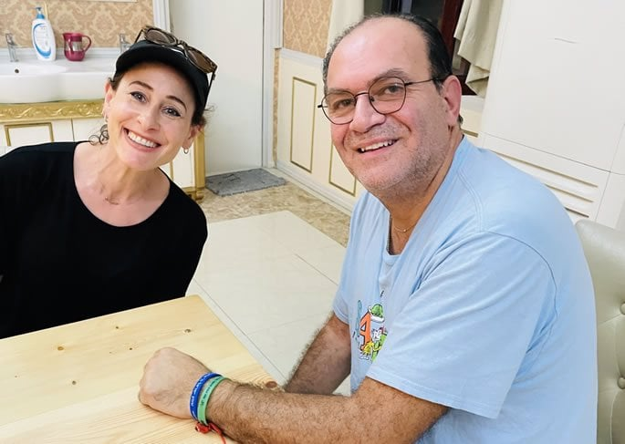
Sam, wearing the shema bracelets, along with the author.

His name is Sam. Sam Cohen, the son of Reuven. And this is his story:
My father was born in Jerusalem and around 1930, he moved to the southern part of Tel Aviv. He never drove a car. His mode of transportation was his bike. He was 87 when he was hit by a motorcycle on December 21. Unfortunately, he wasn’t wearing a helmet. They immediately transferred him to the trauma unit in Tel Hashomer Hospital outside of Tel Aviv.
At the time, I was living in New York. I got a call from my sister that my father wasn’t home and she couldn’t reach him.
We were both worried, and then we heard on the news that there had been a bicycle-motorcycle accident, with the man on the bike in critical condition. I immediately called the hospital trauma unit.
I asked the nurse to please describe the victim, since he could be my father. She was unable to, as his head was encased in a metal piece and his whole body was bandaged up.
I then asked her if the man was wearing a black onyx ring with the initials R.C. for Reuven Cohen. The nurse replied that she herself had taken the ring off his finger when he entered the hospital!
She then told me to hurry up and come. It would take me 16 hours, as I was flying in from the United States.
When I arrived, the doctor told me that with my father’s age, he might survive a few days at the most, but not much longer.

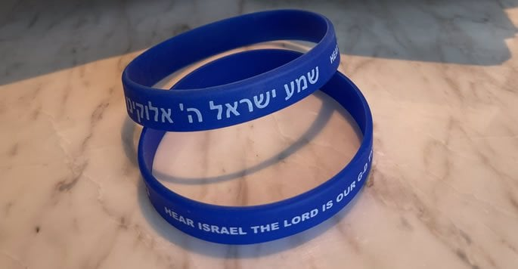
“Doctor,” I said. “You forgot to mention two things: prayers and faith! There are a lot of people praying for my father’s recovery.” The doctor smiled but did not respond.
I stayed by my father’s bedside day and night for three weeks, talking, singing and praying, but there was no movement.

A Flutter of Hope
On a Shabbat morning, at around the three-week mark, I was reciting the Shema aloud.
Although not an observant Jew, my father had always said the Shema every single day.
I got to the part, “And you shall love Hashem, your G-d,’” and my father opened his eyes!
I said, “Abba! Abba! (Father! Father!)” But his eyes closed again.
I screamed for a nurse. But by the time she came, his eyes were closed. They did not believe me.
I repeated the Shema prayer and again he opened his eyes. The nurse was shocked and tried to resuscitate him, but it didn’t work. The good news was that I knew my father could hear me.
I stayed in Israel for another three weeks, but my father’s condition remained unchanging. The doctor told me to go back to New York and my family. They would call me if things got better, or G-d forbid, worse.
By mid-February, I got a call at my store. It was Dr. Ben-Simon. “Hello Sam,” he said, “I have one word for you: a miracle! Your father woke up and guess what he’s doing? He is mumbling the Shema prayer and pedaling with his feet as if he is riding a bicycle!”
“I’ll be there by tomorrow,” I told the doctor.

Partial Recovery
After spending a week in the hospital, I was finally able to take him to an assisted-living facility. It was a long and arduous process, but thank G-d, he lived. He turned 88, then 89, and he even got to his 90th birthday. His birthday is in March, on Purim day, so I came from New York and spent the month celebrating life with him.
Thank G-d, my father healed better than the doctors expected. He recovered and retained his brain function. He could still speak five languages: Yiddish, Hebrew, Spanish, Aramaic and English. But unfortunately, he had lost his memory. He could not remember my name.
One night, right before Purim, I came to visit him, and he said my name. “Sam,” he said. “I’m soon going to heaven.” I felt like it was a spiritual moment. I was in shock and said, “Father, do you know who I am?”
He replied, “Sure, I know; you’re my son, Sam.” I then told him what had been going on for the past two years.
As we were talking, an airplane flew by in the sky, and he pointed up and said, “Soon I will be going to heaven.”
“Not yet, Abba,” I said.
After Purim and all the celebrations, I returned to New York. At 4 a.m. on May 3, 2013, I got the dreaded phone call. Abba had passed away.

Shema Bracelets
In his memory, I decided to make these wristbands with the Shema prayer. I felt that the Shema is what roused him from his coma. Also, he loved saying it every day.
I travel a lot for business, so I gave out these wristbands all over the world. I was in Israel one week and I gave a man a lift from Kfar Chabad. I kept count of each bracelet I gave away, and I was up to number 770. I decided to give this man a bracelet and told him that it was my 770th. He told me he would be traveling to 770 (Eastern Parkway in Brooklyn, N.Y., headquarters of the Chabad-Lubavitch movement). I love Chabad and was so delighted. G-d was smiling down at me.
The Helmet Project
G-d continued to smile His countenance upon me. I wanted to do something else in his honor but couldn’t come up with the right project. I rented a bike and rode the streets of Tel Aviv, with my helmet on, where my father used to ride every day.
It then hit me that too many Israelis were not wearing helmets! I would make helmets and give them out in my father‘s memory. On the helmet, I would write: ‘Wear a helmet. Save your life.’
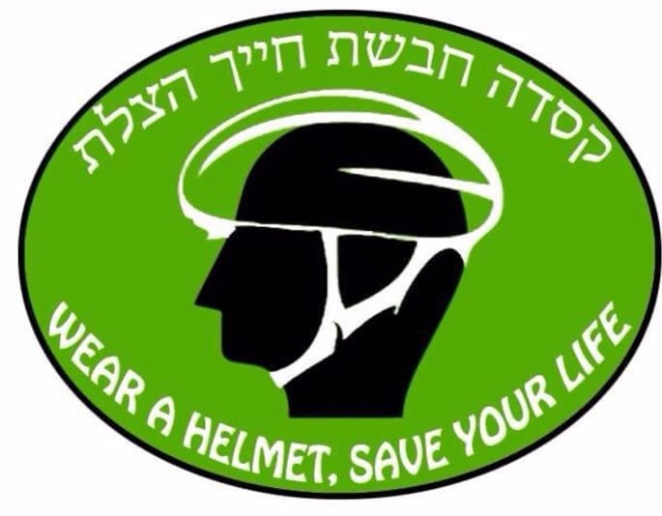
As soon as I got to New York, I had 350 helmets made, and on my next trip to Israel, we gave out the helmets, T-shirts, pamphlets and stickers. We drove around Israel giving them out. It felt cathartic.
One Sunday, my wife and two daughters joined me to give out the helmets. We came to Masada and decided to climb to the top where there is a small synagogue. There was a sofer there, a scribe, writing a Torah scroll.
As I got closer, my daughter pointed out that the scribe was writing my father’s name. I was shocked and took a closer look.
Indeed, the scribe was writing this verse from the Torah portion of Matot: “The descendants of Reuben and Gad had an abundance of livestock.”¹ I was there with my wife and children, and I felt G-d had shined His light on me once again. The scribe was so touched that he dedicated the verse to my father.
I could feel my Abba’s pride in me, the family that I’ve built, and the project I was doing in his memory. It was a glorious moment.
Giving out these helmets could save one person’s life, and as we know, “He who saves one life is as if he has saved the entire world!”² I felt I had made my father and G-d very proud.
May G-d keep shining His light and His miracles on me, my family and all of Israel!

FOOTNOTES
1. Numbers 32:1.
2. Sanhedrin 37a.

Reprinted from a recent website of Chabad.Org

Judging Others Favorably #240
Is this Really Proper
Shabbos Hospitality?

I should have allowed myself more time to travel to my Shabbos destination! I was running late, and hadn’t figured in traffic into my travel time. I knew it was irresponsible. So, I decided to stop in a community in which I knew absolutely no one, counting on my fellow Jews being praised as “mi ke’amcha Yisroel” in their chessed.
I parked my car in front of a house that had a mezuzah, and decided to try my luck. I was glad the man who answered the door was frum. After I explained that I wouldn’t be able to reach my destination before the onset of Shabbos, and needed a place to stay, the man was welcoming, but on one condition.
He said that he could only accommodate me if I gave him a considerable sum of money for my Shabbos stay. I was taken aback, but with sunset approaching and no other option, I reluctantly agreed. I gave him a nice sum of cash.
After we returned from Maariv that night, I enjoyed a nice se’udah with my hosts. They were nice and decent people, but I could not help feeling somewhat resentful that they had demanded money for my Shabbos stay. Well, so much for my hosts being the “mi ke’amcha Yisroel” type!
But I decided that since I was paying for it anyway, I might as well get my money’s worth. I had no compunctions about eating to my heart’s content, taking second and third servings of the various dishes served. I probably gained a few pounds that Shabbos, but I was determined to get my money’s worth from this host whom I thought was rather brazen for charging me for the Shabbos, taking advantage of my need, even though he was not obligated to host me for free.
What happened to chessed? What kind of upbringing did he have? Didn’t he ever learn about hachnosas orchim? Before I departed on Motzoei Shabbos, my host told me that it was his custom to give a gift to each of his guests so that they would remember him. I thought to myself, “You don’t need to give me a gift to remember you! I’ll never forget this experience as long as I live!”
My host handed me an envelope containing the exact sum of money that I had given him for accommodations and meals. I asked, “Why did you return the money I gave you?”
He explained that he only took it to make me feel comfortable. He wanted me to unhesitatingly eat to my heart’s content without feeling embarrassed of being the recipient of a last-minute kindness.

Reprinted from the Parshas Chukas-Balak 5783 email of The Weekly Vort.

The Delicious Shabbos Fish

When Rav Hirsh Leib of Alik, zt”l, was a young man, he lived in his father-in-law’s house for a while. One Erev Shabbos, a government agent arrived in town. The purpose of his visit was to investigate Rav Hirsh Leib’s father-in-law, to see if he was paying sufficient taxes on the liquor he imported and sold.
Rav Hirsh Leib’s father-in-law was very concerned about this, because he knew that government officials were often antisemitic, and once they launched an investigation, they would often make up charges, even if everything was in order. In his distress, Rav Hirsh Leib’s father-in-law asked his son-in-law what to do.
Rav Hirsh Leib asked his father-in-law whether the fish in honor of the approaching Shabbos had already been cooked. His father-in-law replied that indeed it had. Rav Hirsh Leib took the pot of fish and placed it behind the door that led to the liquor cellar. When the tax agent came and opened the door to the cellar, he stopped short. He asked, “What is that delicious fragrance I smell?”

The father-in-law replied, “It must be the fish we cooked to honor the holy Shabbos.”
The tax agent was skeptical. He said that he had never before smelled anything quite so heavenly, and exclaimed, “It can’t be that the source of such a wonderful fragrance was a pot of fish!”
Reb Hirsh Leib offered the tax agent a piece of fish to eat. The tax agent accepted, and he was served a plate of fish. After tasting the fish, the agent was overcome with ecstasy. He had never in his life tasted anything so delicious. He declared, “A Jew whose Shabbos fish tastes like this cannot possibly be cheating with his taxes!” He left the house without bothering to conduct an investigation!

Reprinted from the Parshas Chukas-Balak 5783 email of Rabbi Yehuda Winzelberg’s Torah U’Tefilah.

The Unexpected Gardiner

Rav Yisroel Zev Gustman, zt”l, the Rosh Yeshivah of Yeshivas Netzach Yisroel, had the interesting practice of regularly watering the plants and trees outside his Yeshivah. He always insisted on doing this himself, and he never allowed any of his Talmidim to assist him.
Those who observed him were always so curious why such an esteemed Rosh Yeshivah was always so insistent on doing this. He was known more for being a tremendous Masmid, whose every second was so precious!
One day, Rav Gustman finally explained to them why this was so important to him. He explained, “When I was younger, my Rebbi, Rav Chaim Ozer Grodzinsky, zt”l, took me on a walk in the woods, and he pointed out different plants that were growing around. He taught me which plants in the forest were edible, and which ones were poisonous.
“At the time, I didn't understand why it was necessary to know this, but years later, when I was fleeing from the Germans and hiding in the forest, this advice came very handy, and I was able to survive by eating the edible plants that I learned from my Rebbe. Out of gratitude to the plants that helped sustain me during those difficult years, I took upon myself to water them regularly. Despite being a Rosh Yeshivah and having a busy schedule, I could never stop from expressing my appreciation!”

Reprinted from the Parshas Chukas-Balak 5783 email of Rabbi Yehuda Winzelberg’s Torah U’Tefilah.

In His Hands

There is a story in Living Emunah 3 about a businessman on a flight, seated next to an unaccompanied little girl. After the plane took off, she took out her crayons and coloring book and happily kept herself occupied.
About an hour into the flight, the aircraft suddenly experienced extreme turbulence. The pilot’s voice came over the PA system, asking everyone to fasten their seatbelts and remain calm as they encountered rough weather. The plane made drastic dips and turns and shook for the next half hour.

The Eight-Year-Old Girl Sat Quietly
People were crying and praying; the businessman was sweating and holding on to his seat as tightly as he could. Meanwhile, the little girl, about eight years old, sat quietly. Her crayons and coloring book were put away neatly in the seat pocket in front of her, and her hands rested folded in her lap. She was the picture of calm.
When the turbulence ended and the plane finally began its descent to land, the man asked the little girl, “How did you manage to remain calm the entire flight, especially since you are here all alone?” She looked at the man and said, “My father is flying the plane. He is the best pilot, and he’s taking me home.”
The little girl felt secure because she was in her father’s hands. When a Jew knows he’s in Hashem’s hands, he has peace of mind. Don’t hit the rock; remember that we depend on Hashem, and He will always care for us, whether it’s health, financial success, a shidduch, or anything else!

The Father’s Numerous Trials and Tribulations
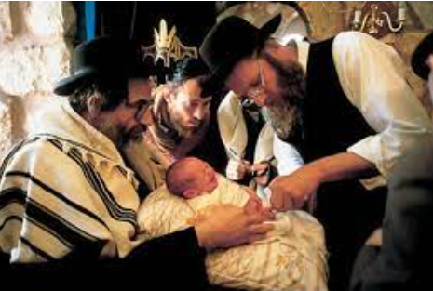
Rabbi Zev Smith recounted that he once attended the brit milah of a boy who was the first child of a couple who had been married for 20 years. The father stood up to speak and emotionally described the trials and tribulations that he and his wife had gone through. “I’m sure you can imagine,” he told his guests, “All the blessings we received from rabbis, and all the heartfelt prayers we recited.” He then proceeded to tell how he made a point to visit a great tzaddik who was visiting the United States. When he asked the rabbi for his blessing, the rabbi asked if he had been praying.
The man was insulted by the question. “What does The Rabbi think I'm doing for the last 20 years?” he wondered. However, he swallowed his feelings and respectfully told the rabbi, “Yes, of course, I have been praying.”

Do You Believe that Only Hashem Can Help You?
“You don’t understand,” the rabbi replied. “Did you ever pray with the firm belief that Hashem is the Only One Who can help you? Did you ever put out of your mind everything the doctors have been saying, to focus on the fact that this is all the Will of Hashem? Or was Hashem just a side point along with the doctors the whole time?”
The man immediately acknowledged that the rabbi was right. He never really prayed with that kind of emunah. “This child,” the man said at his son’s milah, “is testimony to the fact that when you truly believe that Hashem is the source of your salvation, He comes through for you.”

Reprinted from the Parashat Chukat-Balak 5783 email of Jack E. Rahmey based on the Torah teachings of Rabbi Amram Sananes.

Toras Avigdor Junior
On the Tip of Your Tongue
By Aharon Spetner
Adopted from the teachings
Of Rav Avigdor Miller, zt”l

“Mommy!” exclaimed Shimmy, as he came bursting into the living room shortly before supper. “You’re not going to believe this! You know the Hershkovsky family that just moved in down the block? Well Moishy just told me that they weren’t always frum! And you know what the father used to do before he kept Torah and Mitzvos? He -”
“Shimmy!” Mommy interrupted him. “This sounds like lashon hora! Remember last night that we agreed as a family to be extra careful with what we say, and that it should be a zechus for Tante Rina to find a shidduch?”
Shimmy paused to try to catch his breath, but he was still huffing and puffing in excitement.

Now It’s 6:04!
“B-b-but the sign you put on the fridge says that we are mekabel to not speak about other people from 5 to 6 - and now it’s 6:04!”
“Wait Shimmy, that doesn’t mean...” Mommy started, but Shimmy was too excited.
“I need to call Cousin Pinny right away and tell him,” he said. “Where’s the phone?”
Shimmy skidded over to the phone, but stopped short when he realized that it was inside of a glass case that was locked with a padlock! This was new...
“Mommy, why did you lock the phone? Where’s the key? I need to call Cousin Pinny!”
“Shimmy, Shimmy,” Mommy said. “Why don’t you calm down for a second and catch your breath?”
Shimmy inhaled deeply and counted to ten, he realized that he wouldn’t be able to make the call this second. Mommy motioned to the couch where they both sat down.

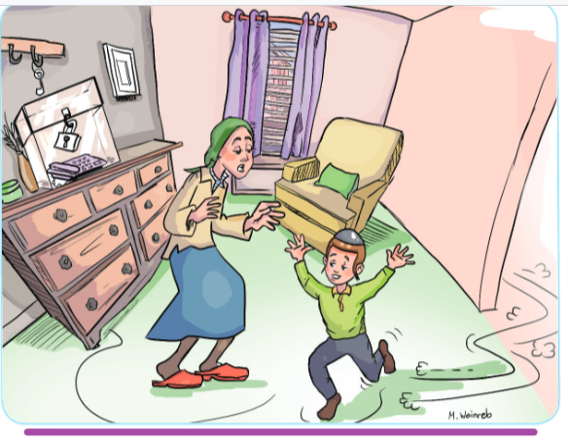

“First of all, Shimmy, just because we are being extra-careful with what we say from 5 to 6, it doesn’t mean that we can just say whatever we want the rest of the day. Lashon hora is still one of the worst aveiros in the Torah. Do you know why?”
“Because we wouldn’t want people to say bad things about us, so we shouldn’t say bad things about other people?”
“Well yes, that is the Mitzvah of “love your fellow Jew like yourself” which one is also transgressing when speaking lashon hora, among many other things. But Rav Avigdor Miller points out two things. First of all, when we say lashon hora we are forgetting that Hashem is always listening, and second Hashem loves all frum Yidden. And when one says lashon hora, he is speaking bad about someone whom Hashem loves! Imagine if someone was in front of a king and while the king was listening, he said something bad about the king’s best friend?”
“Hmmm, I would think the king might have that person killed,” Shimmy said thoughtfully. “Wow I never thought about how bad lashon hora really is. But why did you lock up the phone? How are we supposed to make phone calls?”
“Shimmy,” Mommy said. “Look at the hook right above the phone.”
Shimmy looked and saw that hanging right above the glass box was a key.
“Is that the key to the padlock?” he asked.
“Yes,” Mommy replied with a smile.

The Phone Can be a Wonderful Tool if Used Properly
“Well then what’s the point of locking up the phone if the key is right there?”
“Because the lock isn’t meant to keep us from using the phone. The phone is a wonderful tool if used properly. However, this lock and key is there to remind us that before picking up the phone we need to pause for a second and think ‘what am I about to say on the phone? Is it something that I am better of keeping quiet about?’”
“I like that idea,” Shimmy said with a smile. “But what about when I’m with my friends? I can’t put a lock on my mouth to remind myself not to say the wrong thing.”

Something that is Better than a Lock
“But Shimmy,” Mommy said. “Hashem already gave you something better than a lock. In front of your tongue, Hashem gave you a beautiful set of teeth and lips. Aside from being an incredible gift that helps us enjoy our food, any time we talk, we should feel our lips and teeth against our tongue, and it should remind us to think before we speak.”
Shimmy ran the tip of his tongue along the inside of his teeth and lips. “Thanks Mommy!” he said. “I’m going to try to always use this to remind myself to think before I speak!”
Have a Wonderful Shabbos!

Takeaway:
Lashon Hora is a terrible aveirah because it goes against the first two yesodos of the Torah 1. Hashem is listening all the time. 2. because you’re denigrating a great Jew.

Reprinted from the Parshas Behaaloscha 5783 email of Toras Avigdor Junior.

